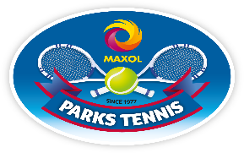
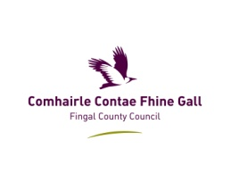
Fingal Parks Tennis Programme
at
Donabate Community College

- Learn to play tennis during early summer
- Classes implemented by Tennis Ireland certified coaches
- All equipment supplied
- All children welcome irrespective of previous tennis experience
- Once-off registration fee for eight-session programme: €25

Registration and coaching begin on Saturday, May 9th, 2015.
Class times: 5/7 years 2pm
8/11 years 3pm
12/17 years 4pm
Adult coaching also resumes on Saturday, May 9th, at 5pm.
Cost: €35 for eight-session programme. All welcome irrespective of previous tennis experience. All equipment supplied.
Programmes implemented in association with the newly-formed Donabate Portrane Tennis Club.
Call 01-8338711 or 086-8351475 for details, or website http://www.parkstennis.com/
Club contact: tennisclubdp@gmail.com

